**Assignment 3**

Aaditya Singh Thakur 21BCY10236

*Understanding SOC, SIEM, and QRadar*

1. A Security Operations Center (SOC) is a critical component of an organization's cybersecurity infrastructure. It serves as a centralized hub dedicated to monitoring, detecting, analyzing, and responding to cybersecurity threats and incidents in real-time. The primary purpose of a SOC is to enhance an organization's overall cybersecurity posture by proactively identifying and mitigating security risks and incidents. Here's a comprehensive overview of what a SOC is, its purpose, key functions, and its role in an organization's cybersecurity strategy:

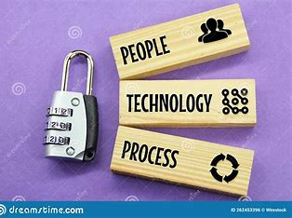

Purpose:

Threat Detection and Prevention: SOC's primary objective is to detect and prevent cybersecurity threats and incidents before they can cause damage to an organization's systems, data, or reputation.

Incident Response: It facilitates a swift and organized response to security incidents when they occur, minimizing their impact and helping the organization recover quickly.

Continuous Monitoring: SOC teams continuously monitor an organization's network, systems, and applications to identify abnormal or suspicious activities that may indicate a breach.

Key Functions:

Monitoring: SOC teams constantly monitor network traffic, log files, and security alerts generated by various security tools and devices like firewalls, intrusion detection systems (IDS), and antivirus software.

Alert Triage: They triage and investigate security alerts to determine their validity and severity. False positives are filtered out, while genuine threats are prioritized for immediate response.

Incident Detection: SOC personnel use advanced threat detection tools and techniques to identify potential threats, such as malware infections, unauthorized access attempts, or unusual patterns of activity.

Incident Response: When a confirmed security incident occurs, the SOC initiates an incident response plan, which may involve containment, eradication, and recovery efforts.

Forensic Analysis: SOC analysts conduct in-depth forensic analysis to understand the scope and impact of security incidents, aiding in recovery and prevention.

Threat Intelligence: They leverage threat intelligence sources to stay informed about emerging threats and tactics used by cybercriminals, enabling proactive defense strategies.

Reporting: SOC teams generate reports and provide insights into the organization's security posture, helping leadership make informed decisions and allocate resources effectively.

Role in Cybersecurity Strategy:

Proactive Defense: A SOC plays a proactive role by continuously monitoring for vulnerabilities and threats, thereby reducing the likelihood of successful cyberattacks.

Rapid Response: In the event of a security breach, the SOC's rapid response capabilities are crucial in minimizing the damage and preventing further compromise.

Incident Recovery: SOC teams help organizations recover from security incidents, ensuring business continuity and minimizing financial and reputational damage.

Compliance and Governance: SOCs assist organizations in meeting regulatory requirements by providing evidence of security controls and incident response capabilities.

Security Improvement: Through ongoing analysis and learning from incidents, SOCs contribute to the improvement of an organization's security posture by recommending enhancements to security policies, procedures, and technologies.

Risk Management: By identifying and mitigating security risks, SOCs contribute to effective risk management, protecting an organization's assets and reputation.

2. Security Information and Event Management (SIEM) systems are integral components of modern cybersecurity strategies. They provide organizations with a centralized platform to collect, analyze, correlate, and respond to security-related information and events from across their IT infrastructure. Here, we'll explore the concept of SIEM systems and explain why they are essential in contemporary cybersecurity:

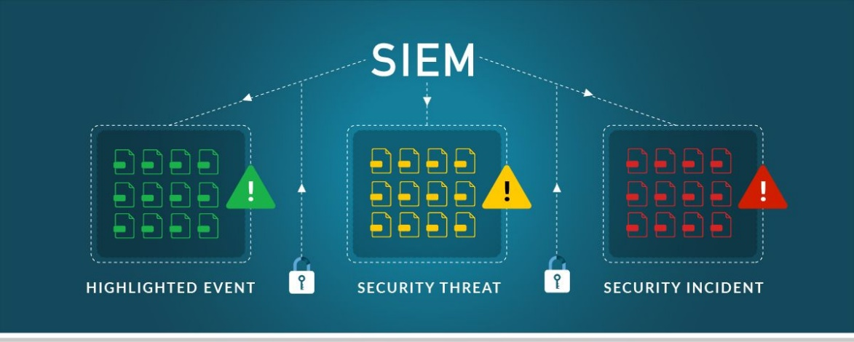

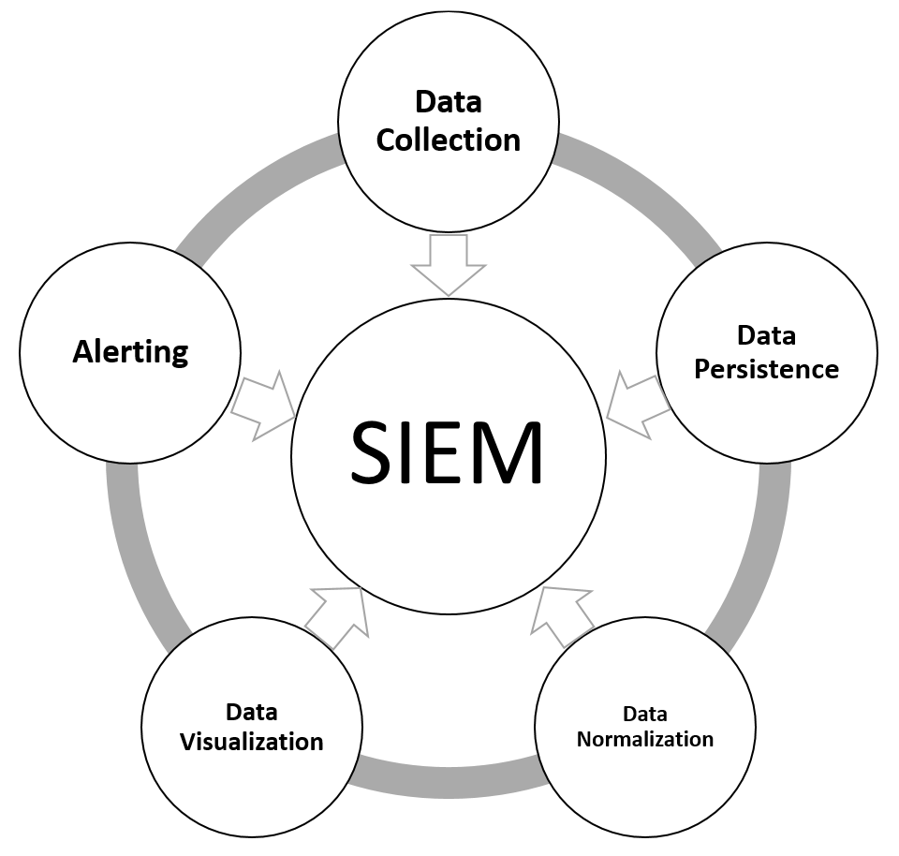

1. Centralized Data Collection:

SIEM systems aggregate data from various sources within an organization's network, including network devices, servers, endpoints, applications, and security tools. This centralized data collection allows for comprehensive visibility into the organization's IT environment.

1. Real-time Monitoring:

SIEM solutions offer real-time monitoring capabilities, enabling organizations to detect security incidents and anomalies as they happen. They continuously analyze incoming data for suspicious activities and potential threats.

1. Log Management:

SIEM systems collect and store logs, providing an audit trail of activities. These logs are essential for compliance, forensic analysis, and troubleshooting. iv. Correlation and Analysis:

SIEM platforms use advanced correlation rules and algorithms to analyze data and identify patterns or anomalies. By correlating seemingly unrelated events, SIEMs can detect complex attack vectors that might go unnoticed by individual security tools.

1. Alerting and Reporting:

SIEMs generate alerts and reports based on predefined rules and thresholds. Security teams receive notifications for potential security incidents, helping them respond quickly and effectively.

1. Incident Response:

SIEM systems assist in incident response by providing context around security incidents. Analysts can investigate incidents with the help of historical data, aiding in containment and remediation efforts. vii. Threat Intelligence Integration:

Many SIEM solutions integrate with external threat intelligence feeds, enriching the data with information about known threats and vulnerabilities. This integration helps security teams prioritize and respond to the most critical threats. viii. Compliance Management:

SIEM systems aid organizations in meeting regulatory compliance requirements by facilitating the collection and reporting of security-related data. They help demonstrate adherence to security policies and standards. ix. User and Entity Behavior Analytics (UEBA):

Some SIEM solutions incorporate UEBA capabilities, which analyze user and entity behaviors to identify insider threats or compromised accounts based on deviations from normal behavior.

x. Scalability and Flexibility:

- SIEM systems are scalable and can accommodate the needs of organizations of varying sizes. They can be tailored to specific requirements and can integrate with other security tools.

3. IBM QRadar is a widely recognized Security Information and Event Management (SIEM) solution that helps organizations detect and respond to cybersecurity threats effectively. It offers a range of features, capabilities, and deployment options tailored to the needs of various businesses. Here's an overview of IBM QRadar:

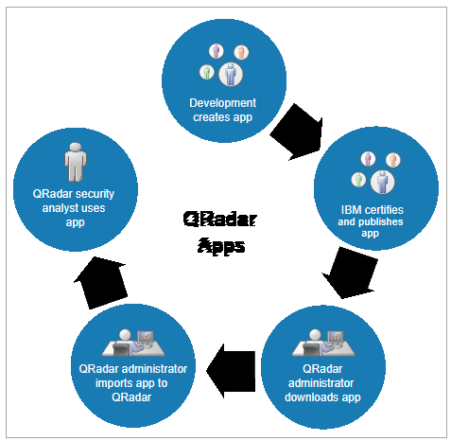

i. Key Features and Capabilities:

Log and Event Data Collection: QRadar can collect data from a multitude of sources, including network devices, servers, applications, cloud services, and security appliances. This extensive data collection allows for comprehensive visibility into an organization's IT environment.

Real-time Event Correlation: QRadar employs advanced correlation techniques to analyze and correlate incoming events and data in real-time. This correlation helps identify patterns and anomalies indicative of security threats, even those spanning multiple systems.

Behavioral Analytics: QRadar utilizes User and Entity Behavior Analytics (UEBA) to monitor user and entity activities. It can detect abnormal behavior patterns and potential insider threats by analyzing deviations from established baselines.

Threat Intelligence Integration: It integrates with external threat intelligence feeds and offers threat feeds from IBM X-Force to enhance threat detection. This helps organizations stay informed about the latest threats and vulnerabilities.

Customizable Dashboards and Reports: QRadar provides customizable dashboards and reporting capabilities, allowing security teams to create and share reports tailored to their specific needs. This aids in compliance reporting and incident investigation.

Incident Detection and Response: QRadar offers automated incident detection and response workflows, streamlining the process of identifying and mitigating security incidents. It supports customizable playbooks for incident response.

Forensics and Investigation: The solution enables deep forensic analysis, allowing security analysts to investigate security incidents thoroughly. It provides historical data and context for incident resolution.

Cloud Support: QRadar offers cloud support and can collect data from cloud-based services and applications, making it suitable for hybrid cloud environments.

1. Deployment Options:

IBM QRadar offers both on-premises and cloud-based deployment options, providing flexibility to organizations based on their infrastructure and security requirements:

On-Premises Deployment: In an on-premises deployment, organizations install QRadar software and hardware appliances within their data centers. This deployment offers complete control over the SIEM infrastructure and is suitable for organizations with stringent security and compliance requirements.

Cloud Deployment: IBM offers QRadar on the IBM Cloud as a Software as a Service (SaaS) solution. This cloud-based deployment option is ideal for organizations looking to offload the management and maintenance of SIEM infrastructure to a trusted provider. It is scalable and allows for rapid implementation.

1. Benefits of IBM QRadar:

Comprehensive Threat Detection: QRadar's advanced analytics and correlation capabilities enhance threat detection by identifying complex attack patterns and potential security risks.

Streamlined Incident Response: The solution's automated incident response workflows and playbooks help security teams respond swiftly to security incidents, reducing response times and minimizing damage.

Scalability: QRadar can scale to accommodate the needs of both small and large enterprises, making it suitable for organizations of various sizes.

Cloud Integration: With support for cloud-based services, QRadar enables organizations to secure their cloud environments effectively.

Threat Intelligence: Integration with threat intelligence feeds and IBM X-Force enhances its ability to detect emerging threats and vulnerabilities.

Customization: QRadar's customizable dashboards and reports allow organizations to tailor the SIEM to their specific requirements and compliance needs.

Centralized Visibility: It provides centralized visibility into an organization's security posture, making it easier to monitor and manage security events and incidents.

4. IBM QRadar, as a powerful SIEM system, can be used in a Security Operations Center (SOC) to detect and respond to various security incidents across different industries. Here are some real-world use cases and examples of how QRadar can be employed effectively:

i. Detection of Insider Threats:

Use Case: An employee with legitimate access to sensitive data starts exfiltrating information for malicious purposes.

QRadar's Role: QRadar's User and Entity Behavior Analytics (UEBA) can monitor user behavior and detect anomalies in data access patterns, such as unusual data transfers or access from unusual locations, flagging them as potential insider threats. ii. Network Intrusion Detection:

Use Case: An attacker attempts to gain unauthorized access to a corporate network through brute force attacks on remote login services.

QRadar's Role: QRadar collects and analyzes network logs, identifying multiple failed login attempts in a short time frame, which triggers an alert. It can also correlate this with other events, such as port scans, to determine if a coordinated attack is underway. iii. Malware Detection:

Use Case: A user inadvertently downloads malware from a malicious website, which then attempts to communicate with a command and control server.

QRadar's Role: QRadar can detect the suspicious network traffic generated by the malware and trigger alerts based on known indicators of compromise (IoCs) or behavior anomalies, helping the SOC respond quickly to quarantine the affected system. iv. Phishing Attack Response:

Use Case: Employees receive phishing emails, and some inadvertently click on malicious links, potentially exposing the organization to malware or credential theft.

QRadar's Role: QRadar can analyze email logs and correlate them with endpoint logs.

Unusual email behavior, such as a spike in suspicious email attachments, can trigger alerts. QRadar can also link these events to compromised endpoints for rapid response.

v. Data Exfiltration Detection:

Use Case: An attacker successfully infiltrates a corporate network and begins exfiltrating sensitive data.

QRadar's Role: QRadar can monitor data traffic and detect unusual data transfers, especially when they deviate from regular patterns or involve unusual destinations, helping the SOC detect and respond to data breaches. vi. Advanced Persistent Threat (APT) Detection:

Use Case: A nation-state-sponsored APT group infiltrates an organization, attempting to remain undetected for an extended period.

QRadar's Role: QRadar can detect subtle and prolonged attacks by correlating multiple lowlevel indicators, such as suspicious system logins, unauthorized data access, and network anomalies, helping the SOC identify APTs and initiate an incident response. vii. Compliance Monitoring:

Use Case: An organization must comply with industry-specific regulations (e.g., PCI DSS, HIPAA).

QRadar's Role: QRadar helps automate compliance monitoring by collecting and analyzing relevant logs, generating reports, and alerting the SOC when compliance violations are detected, ensuring adherence to regulatory requirements. viii. Cloud Security Monitoring:

Use Case: An organization utilizes cloud services and wants to ensure the security of its cloud-based assets.

QRadar's Role: QRadar can integrate with cloud services, collecting and analyzing logs and events from cloud environments to provide visibility and security monitoring, helping detect unauthorized access or data exposure in the cloud.